PRACTICAL NO. 04

- Configure Routers:

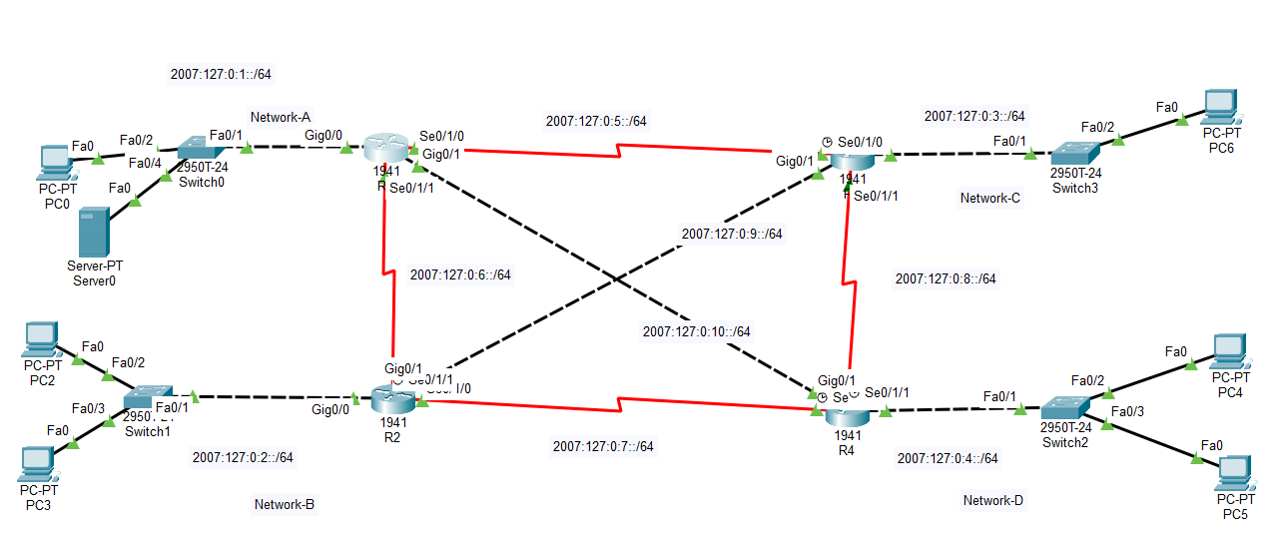

Enable IPv6 on Router
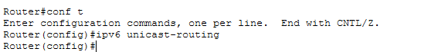

Configuring the IP address of IPV6
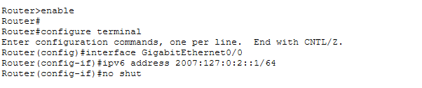

Creating the Riping Process

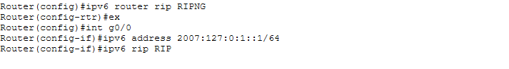

Enabling RIP on Each Router
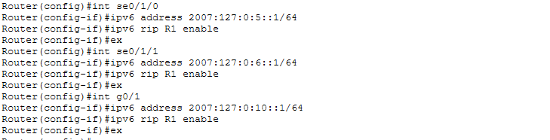

Ping from LAN 2001:160:0:2::2 to LAN 2001:160:0:1::2
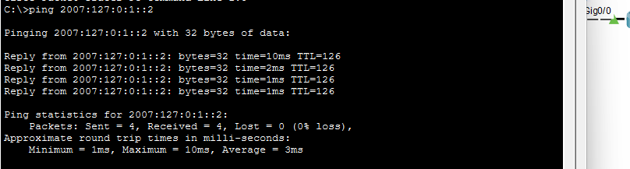
IPv6 Access List: NET-ACCESS

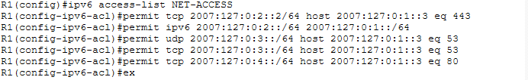
Implement the ACL rule on an Interface
To view the Implemented ACL
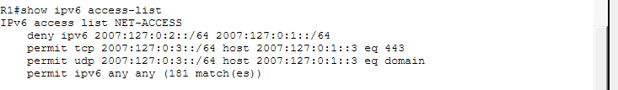

Accessing from Network C to HTTPs service.
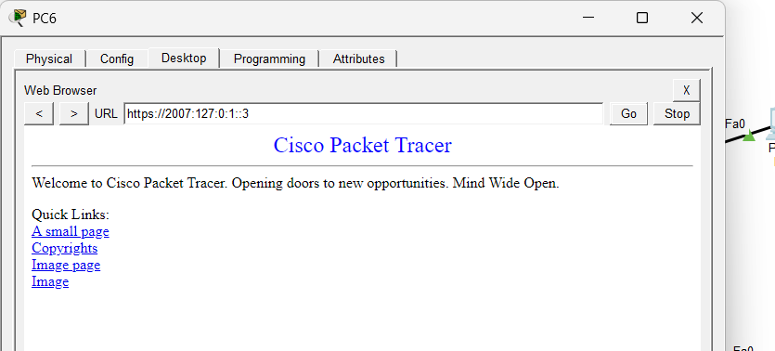

Accessing from Network D to Network A
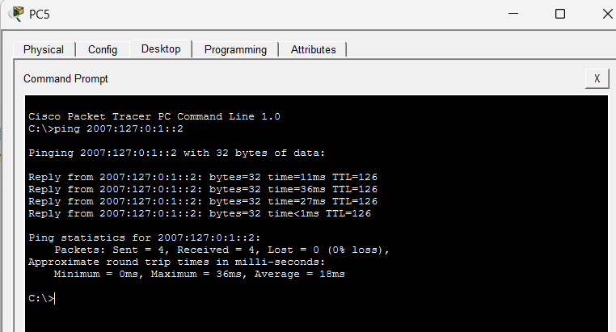

Accessing from Network B to A which should fail
